Faryal Choudhary
Annotated Bibliography
October 13, 2014

Name: Faryal Choudhary
Content Area: World History
Topic: Ancient Greece and Rome
Grade Level: 10th
TEKS Addressed:
(c) Knowledge and skills.
(1) History. The student understands traditional historical points of reference in world history. The student is expected to:
(B) identify major causes and describe the major effects of the following
events…the development of the classical civilizations of Greece, Rome…
Rationale:
Because so much of how our government and world works has been influenced by Ancient Greece and Rome, it is important to study the origins of the workings of our modern world. World history that is taught in high school has to cover an extremely large period of time, and therefore must be broad in order to learn all the “necessary” information. The students learn that democracy comes from Greece, and the success of an empire is modeled in Rome, however, they do not get a chance to delve into the details.
We study the ancient world to marvel at their innovations, inventions, philosophies, prowess, and influence on the rest of the world. But we also study it to compare and contrast the world of antiquity to that of our own. To gauge our morality, humanity, and societal norms and rules versus the ones of the past, and, to oftentimes stand shocked at the differences. The ancient world is not like our own: it was a much harsher, crueler, and more violent time. However, many of the ideas and teachings have made a lasting impact on our world came from theirs.
Ancient Greece and Rome are fascinating, and, as a (perpetual) student of history, my favorite time period. The information in this library will be related to the civilizations of Ancient Greece and Rome, but will allow for a more in depth understanding of life in that time period. The characters that lived and dominated in those times were larger than life, and can teach us lessons beyond where our government systems came from. The lessons of the past teach us where we can go. Understanding historical context helps us understand the world we live in by examining the origins of our way of thinking.

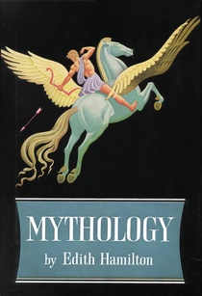
1. Hamilton, E. (2013). Mythology. New York City: Little, Brown and Company.
Text Type: Narrative

Summary:
In this anthology, Edith Hamilton tells the stories of mythology that made up the religions of the Ancient Greeks and Romans. She begins with the origins of the gods, and then continues into the specific myths of some of the most famous individuals to come from antiquity, particularly of the Greeks. Hamilton tells the stories of not only the gods, but of the heroes who played a major role in Greek and Roman history and mythology. Perseus, Theseus, Hercules, and Jason and the Argonauts, are amongst some of the heroes mentioned. Love, war, and family played a role in Greek and Roman life, and those ideas are addressed through the myths related to each topic.
Analysis/Evaluation:
I initially read this book in high school in a mythology class and thought most of the stories in the book were short and easy to read. The writing is a bit old, as Hamilton initially wrote the book in 1942, however, it is not difficult to understand. This book would be considered appropriate for anyone to read, although English Language Learners may have more trouble than others with the text, as pictures and visuals are limited. This is a good introduction to the religion of the ancient world, and helps explain the role it played in daily life. A lot of terminology we use today originated from mythology, and this text helps give understanding to those terms, as well as helps expand vocabulary. The only part of this book that is not appropriate for the TEKS is the small section in the back related to Norse mythology.

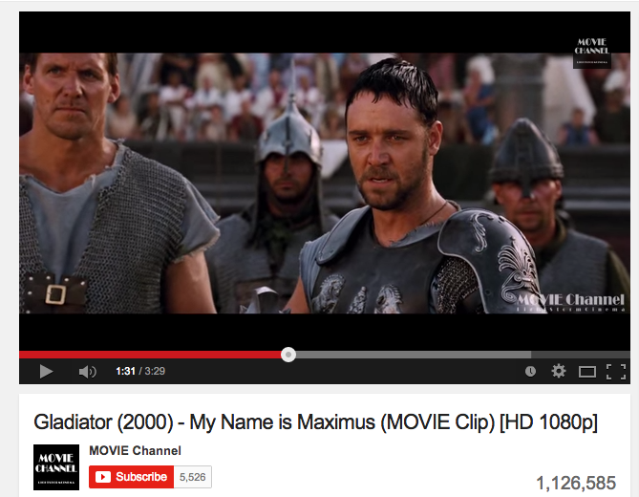
2. Wick, D., Franzoni, D., Lustig, B. (Producers), & Scott, R. (Director). 2000. Gladiator (motion picture). Retrieved from https://www.youtube.com/watch?v=oSomiNeUIfY.
Text Type: Auditory/Visual YouTube clip

Summary:
In this three and a half minute clip from the movie, the importance of the crowd and an individual’s popularity in the choices of an emperor are shown. Although it is clear that the emperor does not want to spare the main character, he is obliged into catering to the wants of the crowd who come to be spectators at the gladiatorial games. This particular scene does not show the bloody violence of the actual fights, although there are plenty of those scenes in the rest of the movie.
Analysis/Evaluation:
The clip illustrates the power a crowd can have over a person, trumping his or her own personal desires in order to “follow the crowd.” Not even the emperor could turn down the desires of his people in a situation such as the gladiator games that took place in the Colosseum. Emperors would put on these lavish and violent “games” for the Roman people in order to celebrate military victories, religious holidays, and various other reasons. This clip, and the movie in general, although somewhat historically inaccurate, are good depictions of the reality of the gladiatorial games and bloodlust of the crowds who watched them. The value on human life seems to be little to none in this movie, illustrating the bloodshed that took place in the ancient world, both in daily life, and in order to expand such a large and powerful empire. This source is a good reference for ELL students, as it is very visual and easy to understand. An unmotivated student could also be interested, as it is not reading and “outside” the realm of education.
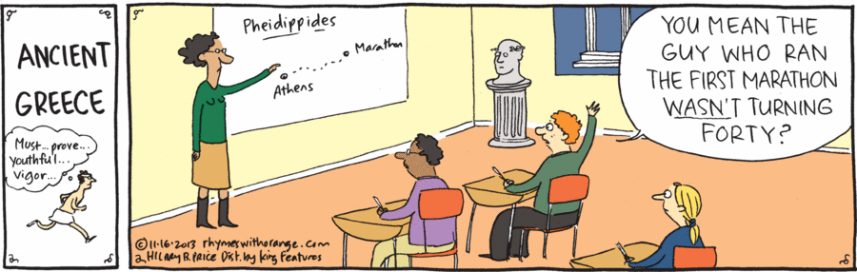
3. Price, H. (2013, November 16). Ancient greece. (Cartoon). Rhymes with orange. Retrieved from http://rhymeswithorange.com/comics/november-16-2013/.
Text Type: Narrative/Comic Strip
Summary:
In this comic, the teacher is explaining to the class the importance of the running from Marathon to Athens by the messenger Pheidippides. The student seems to misunderstand the motivation behind the running, or it’s (possible) historical context, thinking of the context of who or what a marathon runner is today.
Analysis/Evaluation:
Most people, young, high school aged student included, know what a marathon is and how long of a running distance it entails. What many people don’t know is the historical context behind that particular distance. Although it is not entirely historically proven, the running took place between Marathon and Athens, covering a distance of twenty-six miles. The runner, Pheidippides, upon arriving in Athens was claimed to have given information about the Greek victory over Persia using his last breath. In a student’s modern context, marathons are typically run by older people who are wanting to get into shape, indicating a middle age crisis, as alluded to in the comic. Since many high schoolers parents might be likely to run in marathons, they would finally be able to understand some of the context behind the reason why a marathon is as long as it is. This source would be well for all readers, but could serve well for a struggling reader, as it is not a traditional reading material. This could also work well for an unmotivated learner as well, since it is a resource not wholly related to education. An ELL student may have difficulty with this source, if he or she is unfamiliar with the typical stereotypes that are associated with marathon running.

4. Gibbon, E. (2004). The decline and fall of the Roman empire (Vol. 1). J.B. Bury (Ed.). Maryland: Wildside Press.
Text Type: Expository
Summary:
Chapter four, parts one and two, of volume one of Gibbon’s book, is aptly titled “The Cruelty, Follies and Murder of Commodus.” Edward Gibbon, an 18th century parliament member and historian, used primary sources to write about the Roman Empire, marking him as model for later historians. In these parts of the chapter, the beginnings of the rule of Commodus are described, as well as his degeneration into cruelty (marked by heavy violence), megalomania, and vice. His financial expenditures, gladiatorial escapades, and unwarranted executions of nobles and senators are cited as examples of his tyranny, which led to his eventual assassination. Commodus’ death ended the Nerva-Antonine, also known as the Reign of the Five Good Emperors, however, Commodus is not considered to be one of those five, as the end of his reign saw the depletion of the treasury surplus that was left at the end of his predecessor’s reign.
Analysis/Evaluation:
Edward Gibbon wrote his history of the Roman Empire in the 1700s, and therefore is not the easiest of texts to read and understand initially. Due to the somewhat challenging nature of the text, the inclusion of this entry is aimed at the gifted and advanced readers and learners in the classroom. It can be seen as an example of texts that one would encounter in the world of professional historiography, as well as a text in a college-level course. This text also serves as an example of the behaviors exhibited by the more tyrannical and reckless rulers of Rome, as well as an indication of the beginning of Rome’s decline. Parts of Gibbon’s text refer to ancient Greece as well, linking the two cultures of antiquity to one another and showing the influence of Greece on Rome.

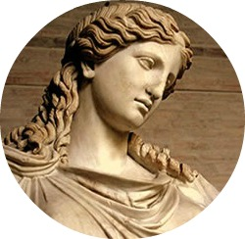
5. classicsenthusiast. The classical world. (Tumblr blog). Retrieved from http://classicsenthusiast.tumblr.com/.
Text Type: Electronic Text Blog

Summary:
This Tumblr blog about the Classical World includes posts predominantly about Ancient Greece and Ancient Rome. The posts that are blogged or re-blogged include pictures of art, architecture, literature, and other archaeological finds, as well as linguistic information, including words of Ancient Greek or Latin origin.
Analysis/Evaluation:
This source for the library is accessible to all students, and is particularly helpful to those students who are more visual learners. The prevalence of pictures allows for an appreciation of the art and architecture that we see influence our own society today. The inclusion of literature and word definitions is beneficial for students who prefer to read text rather than photos. This blog also allows the students to see that there are many people outside of school settings who have an ardent interest in history. A classroom blog could be set up, allowing each student access to Tumblr. If a student sees something he or she likes or thinks relevant to the library (or any historical period studied in class), they are more than welcome to reblog that post so that their classmates and teacher can also see the post and learn from it. Since students are very familiar with technology, this could be used as a relevant resource that they can access outside of school as well. Because of the modernity of the blogs on Tumblr, the unmotivated students who has interests elsewhere would benefit from this, as it could be seen as lying outside of scope of a traditional educational setting.

6. Roman empire & colosseum. (2014). Retrieved October 13, 2014 from http://www.tribunesandtriumphs.org/.
Text Type: Electronic text website
Summary:
This website is a resource for information about the Roman Colosseum, as well as other information related to Ancient Rome. It provides introductory information on gladiators, emperors, the Colosseum, Roman architecture, the Roman Empire, clothing, Roman life, gods, Roman weapons, and the Roman Army. This site includes a history of Rome, beginning with its formation as a monarchy and its transition into a republic and then an empire. The biggest focus of the website is the Colosseum, known as the Flavian Amphitheater in its day, and its impact on the lives of the citizens around it.
Analysis/Evaluation:
No aspect of a society can stand alone, and this website allows for an understanding of the linkages between the different aspects of Roman life. The Flavian Amphitheater played a fairly central role in everyday life, as it’s architecture was inspired from ancient Greek amphitheaters, and served as a location for entertainment. The Colosseum is one of the lasting buildings of ancient Rome, despite its current decaying and decrepit state. Regardless of its existing condition, most people are aware of the importance of the Colosseum and its representation of Ancient Rome. This website would be a resource for all students, although ELL students may have trouble with the heavy usage of terms and vocabulary related to ancient Rome.

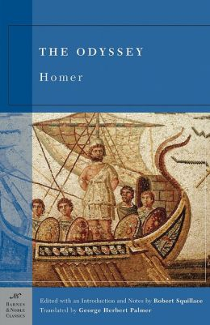
7. Homer. (2003). The odyssey. New York: Barnes & Noble Books.
Text Type: Narrative
Summary:
In this classic book written by Homer, a Greek hero from the Trojan War, Odysseus, returns home. He has been away from home for ten years, the duration of the war, and now makes his way back to his family and people, which ultimately takes him another decade. Odysseus is king of Ithaca, whose wife Penelope, and son, Telemachus, must fend off suitors for the queen who are after the throne. During his odyssey home, he encounters many obstacles, including his extended stay on Calypso’s island. Finally returning home, Odysseus, his son, the goddess Athena (his protector), and many others loyal to the king of Ithaca, come together to kill all the suitors who have intruded upon Odysseus’ hospitality in his absence. He convinces both his wife and father of his identity and is welcomed home with loving arms.
Analysis/Evaluation:
This book on the library could be accessible to everyone, but could prove to be a somewhat difficult text for any ELL students or struggling readers, as the translation isn’t necessarily in the vernacular of high school students. The words themselves are not extremely difficult, however, the sentence structure makes the reading more cumbersome than the students may be used to. For the unmotivated student, this text could be offered with supplemental adaptations (e.g. the film O Brother, Where Art Thou?). This book is seen as a classical example of Greek work that is oftentimes considered a “required” reading in schools (in conjunction with The Iliad, which tells the story of the Trojan War). The insights into Greek life and culture (i.e. hospitality towards guests) are telling, as the idea of hospitality is prevalent in many cultures and societies to this day.

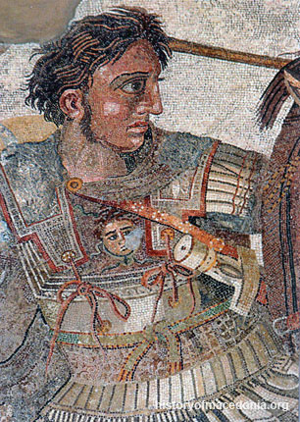
8. Alexander the great. (2013). Retrieved October 15, 2014 from http://www.historyofmacedonia.org/AncientMacedonia/AlexandertheGreat.html.
Text Type: Narrative biography
Summary:
This article is a biography of Alexander the Great, ruler of Macedonia and conqueror of Greece and much of the ancient world. Alexander began conquering his surrounding world at a very young age and proved most adept at military strategy. The article discusses his early life, but focuses heavily on his military battles and conquests. Images of Alexander the Great are also extensively; maps that depict the expansion of his empire are also featured, emphasizing the enormity of his conquests and actions. His lasting legend and impact on the world are mentioned. Alexander the Great died at the age of thirty-three without naming an heir, which led to civil unrest and ultimately, to the disillusion of the Macedonian Empire he worked so hard to create.
Analysis/Evaluation:
Alexander the Great was a great military mind who is still revered to this day. His legend lives well into modern times, and he was greatly admired and respected by later Greeks and particularly by the Romans. His tomb was a pilgrimage site for many Roman emperors, who strived to attain his impressive feats of military conquest. The influence of Alexander the Great and his expansion of Macedonia led to a great impact on all parts of the world, particularly in Asia. The artistic style associated with him, Hellenism, still can be seen in the world. This article is meant for all readers, as the many visuals provide insight for ELL and struggling readers. Unmotivated students might also take particular interest in the militaristic style Alexander the Great exuberated. Advanced readers and learners can use this source as a starting point for greater in depth research on the Macedonian king.

9. Sophocles. (1973). Antigone. (Richard Emil Braun, Trans.). New York: Oxford University Press. (Original work ~ 441 BCE).
Text Type: Narrative
Summary:
This play is the third part of a trilogy written before or around 441 BCE by Sophocles. Although meant as the third part, it was written first, and stands as a testimony to the importance of upholding the values and virtues dictated by Greek religion and gods. Antigone cannot allow her brother’s body to remain unburied, despite a decree from the king, her uncle, Kreon, claiming her brother to be an enemy of the state. As such an enemy, he is to be made an example and left unburied, fodder for vultures. Antigone’s conviction in her religion, the decree of the gods, and love for her brother motivate her to go against the king’s commands. As a result, her punishment is death—a fate her fiancé, the king’s son, bemoans. Ultimately, the king realizes that he is wrong in his sentence of execution, but too late. Antigone, his son Haimon, and his wife Eurydice all end their lives in grief.
Analysis/Evaluation:
Greek tragedies are the template for dramatic tales of woe. Many of the characters’ lives end in death, as do many of the tragic Shakespearean characters. The plays are an influencing factor for other playwrights, however, the message of Antigone reflects on the religious ideas and notions of honor in Greek society. Antigone refers to the laws of the gods as superior to the laws of man, and therefore her motivation in her actions. These ideas exemplify the values, virtues, and principles that guided everyday Greek life. Some of the notions exhibited by the characters in the play are ideals still valued today. This text is straightforward enough to be accessible to all the students, except perhaps the ELL ones. Since Antigone is a play, however, visual representations of the ideas written by Sophocles are available for those students, and the ones who learn in a more visual manner. A struggling reading student, as well as one interested in theater and the arts would also benefit from a visual version of Antigone.

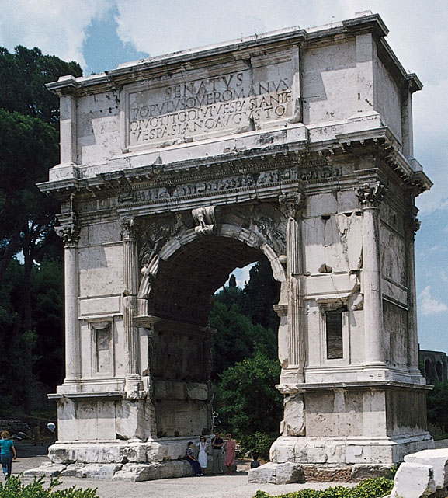
10. Roman architecture. (2013). Retrieved October 15, 2014 from http://www.oneonta.edu/faculty/farberas/arth/arth200/politics/roman_architecture.html.
Text Type: Electronic website
Summary:
This source discusses the different types of Roman architecture and how some of the buildings formed the basis of governmental buildings still in use today. Modern architecture is also mentioned, as well as the Pantheon, built by the emperor Hadrian. The Pantheon serves as an influence in many buildings, both religious and civic. The source is also supplemented with many images of the architecture mentioned, both ancient and modern.
Analysis/Evaluation:
The longevity of Roman architecture is evident even in modern buildings. The structures, shapes, and basic engineering ideas used then are still utilized today. This particular source contains many images of buildings, making it a source for all the students in the class, including any ELL or struggling readers. Students can see these images and then go to their local legislation buildings to notice the similarities. The ideas of Roman architecture did not end in Rome, but made an impact throughout the world, particularly in the West.
Reflection
Process:
The process for finding the sources used in this annotated bibliography varied in ease. As someone who already has a great interest and admiration in and for ancient Greek and Roman world and culture, some of the ideas for the sources popped immediately into mind. The ones that came easily included the Edith Hamilton book on mythology, as well as the scene used from the movie Gladiator.
The book on mythology is available at any bookstore, as it is a well-known and used text in the teaching of mythology. The scene from the movie was a little harder to pin down, as initially the scene I wanted to include was bloodier than the one that ultimately ended up in the library. Gladiatorial fights played a major role in the Roman world, even the emperor Commodus took part, and the bloodshed that typified this entertainment speaks volumes of the mindset of the society. A book that I would’ve liked to include but didn’t due to its unavailability in stores is called The Gladiators: History’s Most Deadly Sport. It goes in more detail about the gladiatorial games and environment.
The inclusion of the Greek writings of Homer and Sophocles were also easy sources to find and include, as they are also found in major bookstores. They exemplify the writings, stories, and principles of ancient Greek society and culture. Putting a part of the work of Edward Gibbon was also a choice I thought would work well for more advanced students, and therefore not a difficult selection. His abridged work is also easily found in bookstores, however, the unabridged version, should one choose to find it, is available on Amazon.
The classical world Tumblr was also not difficult for me to locate, as I already have a Tumblr blog account. I already followed a historical blog on the website and thought that finding one relating to the historical aspects of Ancient Greece and Rome would’ve been a good source to include in the library. Since students have such easy access to the internet and technology, a blog is a source that students can explore without having to be in school. Forming a class blog in order to “pin” interesting posts or ideas is also a way in which to actively include the students and make them feel that they are playing a role in their learning environment.
Finding the websites for Roman architecture, the Colosseum, and Alexander the Great’s biography involved research on the internet but yielded easy results. Using website’s the were .orgs or .edus rather than .coms added to the reliability of the information presented. The most difficult item to find was the comic strip on Ancient Greece, but even this was found relatively easily because of the internet. The gladiator book would have been a nice inclusion, as well as a book about Commodus and the Five Good Emperors (which includes my personal favorite emperor, Hadrian). The latter book would have served as a good example of the importance of not choosing an heir based on blood, however, it was also not in stores and would have to have been ordered online.
Overall analysis:
Overall, I believe that all ten sources used in the library cover a variety of topics related to ancient Greece and Rome. They also offer a variance in the types of sources used, from books to plays to videos to websites to blogs. Visual and auditory learning takes place in more than one inclusion, and reading is available in almost all sources as well. Many of these library selections offer an introduction to the specific topics mentioned, and all allow for an opportunity to delve into greater detail.
For the students interested in arts and theater, the movie clip and play offer one angle of learning the information. If a student wants to see the entirety of the movie Gladiator, he or she is more than willing to rent the movie from their local library or video store. Typically movies can also be found online or on Netflix, which many people have access to. The graphic nature of the film will be disclosed to the students, but given that high school students indulge in many different television shows and movies, violence is likely not a foreign concept. The play allows for an opportunity to explore theater and the student can find a local production of Antigone, or look online for more sources.
Architecture websites and the blog allow for an appreciation or understanding of building structures influence in modern times. It also shows the art that influenced a lot of Renaissance art, including painting and sculpture. Many subjects from ancient Greece and Rome are also depicted in art, not only from antiquity, but in post-classical and modern times as well. A local art museum would be a good source to explore in order to see more of the influence the art has on culture.
Many of the books and readings open up the world of academia in a professional sense for the students, particularly in the work of Edward Gibbon. Gibbon is oftentimes read by college students and offers the advanced readers an opportunity to jump in the shoes of their future, if they so choose. Edith Hamilton’s mythology book provides for an insight into the religion of ancient Greece and Rome, as does the play Antigone. Many of these resources offer an understanding of the society and culture of the ancient world, which varies sometimes so greatly from our own.
Given more time and more money, more books, plays, and movies could be added to the library, as well as sources of art and architecture.

